School District of Turtle Lake
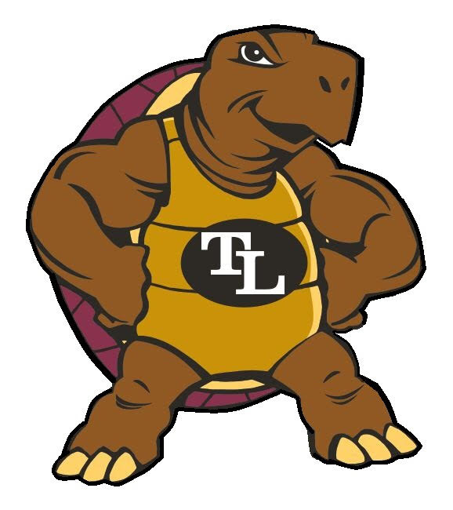
Library Plan 2024-2029
Board Approved 3-14-2024

“The Turtle Lake School community instills excellence in staff and students producing graduates with the knowledge and tools necessary to excel in all aspects of life.”

The School District of Turtle Lake does not discriminate on the basis of sex, race, color, age, national origin, ancestry, creed, religion, pregnancy, marital or parental status, sexual orientation, or physical, mental, emotional, or learning disability.

Introduction
Historically, long-range library plans which are required through Wisconsin Administrative Code PI 8.01(2)(h), have been integrated into the technology plans. With recent changes in requirements and forms of these plans, library plans have been left to stand on their own. Having a long-range plan developed allows our library program to effectively increase student achievement, provide equitable resources to all, and be a key collaborative part of learning initiatives.

Current Library
The library circulates an average of 8,050 materials a year. We contract with Clayton School District for a part-time library media specialist and employ a part-time library aide. We are a member of the Interlibrary Loan system where materials are shared among Wisconsin libraries. The middle school, 4^{th,} and 5th grades compete in the Battle of the Books with support from the library. Teachers have large classroom libraries but these are not part of the school library.

Community Partnership
We partner with the Turtle Lake Public Library for materials and reading to students.
We also participate in the TACOS (Teen Advisory Council Of Students). Students apply and must be accepted to this group. If selected they meet once a month for lunch and do projects to support and promote the library.

Assessment
A survey of staff was conducted in November of 2023.

Goal
Utilize library resources to promote continuous student growth and achievement.

Activities
- Continue to add reading materials to our collection to ensure that students and teachers have access to a variety of resources.
- Encourage staff and student input on purchasing new materials.
- Weed collection to remove outdated materials.
- Provide high-interest titles for our students at all grades.
- Communicate purchasing process and materials available to staff.
- Add displays so that all materials are visible to staff and students.
- Provide a stand-alone computer for searches.
- Streamline the checkout process
- Explore more digital options that students could use on their Chromebooks.
- Provide a list of materials other than books including technology that are available for checkout.
- Keep a rotation of Chromebooks.

Funding
School districts receive an annual distribution of earnings from the Common School Fund. These funds (commonly known as Library Aid) are used to purchase library books and other instructional materials. The Common School Fund uses the annual interest accrued on an investment dating back to 1848. School districts receive an annual distribution of earnings from the Common School Fund. This distribution is based on the number of residents ages four to twenty and the district census count as of June 30 is reported annually. Turtle Lake School’s annual library aid is currently around $20,000.

